1. Remember that “Topic Exchange” also based on “Routing Key” but utilizes regex.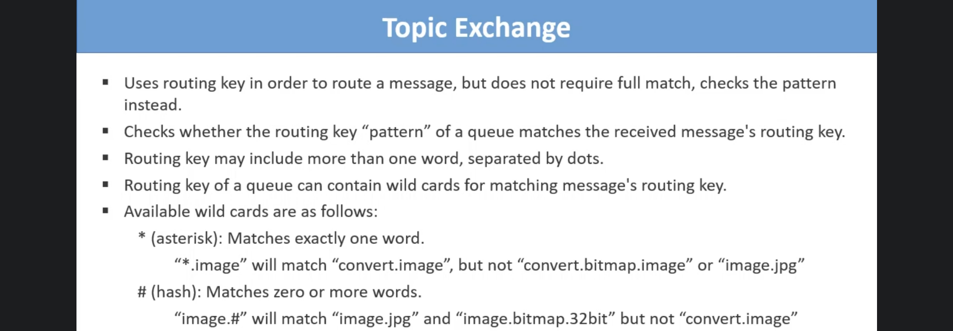
2. 